COMP7108 Project Report

**Feng Binhao 3036379988,**

**Huang Yihang 3036382064,**

**Wang Anji 3036380767**

**(Sort by the first letter of the surname)**

Content

Introduction 2

Tool Overview 2

2.1 Architecture and Core Features 3

2.2 Data Processing Modes 3

2.3 Community Support and Ecosystem 4

Installation & Configuration 4

3.1 Windows Local Installation 4

3.2 Docker-based Installation 11

Exploration & Experiments 12

4.1 Dataset Selection 12

4.2 Basic commands and operations 14

4.3 Advanced functional testing 16

Evaluation & Analysis 31

Reflection & Lessons Learned 33

## Introduction

The ever-growing volume and complexity of data in the modern world necessitate the development and application of advanced big data tools. These tools are designed to efficiently process, store, and analyze massive datasets that traditional data management systems cannot handle. The objective of this project is to provide practical, hands-on experience with a selected big data tool, enhancing understanding of its architecture, installation processes, operational commands, and real-world applications. Through this exploration, we are expected to gain a deeper appreciation of the strengths, challenges, and potential of big data technologies in various industries.

For this project, We have chosen **MongoDB** as the big data tool to explore. MongoDB is a widely used, high-performance, document-oriented NoSQL database designed to handle large-scale, unstructured, or semi-structured data. Unlike traditional relational databases, MongoDB adopts a flexible schema approach, making it highly suitable for dynamic and evolving datasets commonly encountered in big data scenarios. It supports horizontal scalability through sharding, offers powerful aggregation frameworks, and integrates seamlessly with modern application development ecosystems. Furthermore, its native support for geospatial data and time-series collections extends its capabilities to diverse use cases such as real-time analytics, Internet of Things (IoT) applications, and environmental monitoring.

The selection of MongoDB aligns closely with my personal interests and academic focus. We are deeply interested in data management, real-time analytics, and database system optimization, all of which are areas where MongoDB demonstrates significant capabilities. Additionally, given the prevalence of MongoDB in modern data-driven applications, gaining practical experience with this tool complements the objectives of the COMP7108 Network Data Analytics course, which emphasizes understanding large-scale data handling and analytics frameworks. Exploring MongoDB also provides an opportunity to work with real-world environmental sensor data — a type of semi-structured data that is particularly relevant to current research trends in smart cities and environmental monitoring, topics that we find highly engaging.

Through this project, we aim not only to familiarize ourselves with MongoDB’s core functionalities but also to critically evaluate its advantages, limitations, and potential applications in real-world big data environments.

## Tool Overview

In this project, I have selected MongoDB as the big data tool to explore. MongoDB is an open-source, document-oriented NoSQL database designed for scalability, high performance, and ease of development. Its flexible schema and powerful querying capabilities make it suitable for a wide range of applications, from real-time analytics to content management systems.​

### **2.1 Architecture and Core Features**

MongoDB's architecture is built to meet the demands of modern applications, offering a robust set of features: ​[MongoDB](https://www.mongodb.com/resources/products/fundamentals/mongodb-architecture?utm_source=chatgpt.com)

* **Document Data Model**: MongoDB stores data in BSON (Binary JSON) format, allowing for rich, hierarchical data structures. This model provides flexibility in data representation and aligns closely with the data structures used in modern programming languages. ​
* **Sharding**: To handle large-scale data, MongoDB supports horizontal scaling through sharding, distributing data across multiple machines. This ensures high throughput and scalability for big data applications. ​[Informa TechTarget](https://www.techtarget.com/searchdatamanagement/definition/MongoDB?utm_source=chatgpt.com)
* **Replication**: High availability is achieved through replica sets, where data is replicated across multiple servers. In the event of a failure, automatic failover ensures continuity of service. ​[Wikipedia](https://en.wikipedia.org/wiki/MongoDB?utm_source=chatgpt.com)
* **Indexing**: MongoDB provides comprehensive indexing options, including single field, compound, geospatial, and text indexes, to optimize query performance. ​
* **Aggregation Framework**: The aggregation pipeline allows for efficient data processing and transformation, enabling complex analytics operations directly within the database. ​[Stack Overflow](https://stackoverflow.com/questions/73987388/mongodb-big-data-processing-takes-huge-amount-of-time?utm_source=chatgpt.com)
* **ACID Transactions**: Starting from version 4.0, MongoDB supports multi-document ACID transactions, ensuring data integrity across complex operations. ​[Wikipedia+1MongoDB+1](https://en.wikipedia.org/wiki/MongoDB?utm_source=chatgpt.com)

### **2.2 Data Processing Modes**

MongoDB supports various data processing modes to cater to different application needs:​

* **Batch Processing**: Suitable for processing large volumes of data, MongoDB's aggregation framework and MapReduce capabilities allow for efficient batch operations. ​[Wikipedia](https://en.wikipedia.org/wiki/MongoDB?utm_source=chatgpt.com)
* **Real-Time Processing**: With features like change streams, MongoDB enables real-time data processing by allowing applications to subscribe to data changes and react accordingly. ​[Medium](https://medium.com/%40devlexus/real-time-data-processing-with-mongodb-use-cases-and-solutions-91d09a48fb1f?utm_source=chatgpt.com)
* **Time Series Data Handling**: MongoDB offers native support for time series data, providing optimized storage and querying capabilities for time-based data, which is essential for applications like IoT and monitoring systems. ​[MongoDB](https://www.mongodb.com/resources/products/capabilities/features?utm_source=chatgpt.com)

### **2.3 Community Support and Ecosystem**

MongoDB boasts a vibrant community and a rich ecosystem:​

* **Official Drivers**: MongoDB provides official drivers for major programming languages, including Java, Python, C#, and Node.js, facilitating seamless integration into various development environments. ​[Wikipedia](https://en.wikipedia.org/wiki/MongoDB?utm_source=chatgpt.com)
* **Community Forums and User Groups**: The MongoDB Community platform offers forums, user groups, and events that foster knowledge sharing and collaboration among developers worldwide. ​[MongoDB](https://www.mongodb.com/community/?utm_source=chatgpt.com)
* **MongoDB University**: An educational platform offering free courses and certifications to help developers and administrators deepen their understanding of MongoDB.​
* **MongoDB Atlas**: A fully managed cloud database service that simplifies deployment and management, allowing developers to focus on building applications without worrying about infrastructure.​

Through this exploration, we aim to gain a comprehensive understanding of MongoDB's architecture, data processing capabilities, and the support available within its community and ecosystem.

## Installation & Configuration

### 3.1 Windows Local Installation

#### 3.1.1 System Requirements

**Operating System**

* Windows 10 64-bit (Professional, Enterprise, or Education editions) or later.
* MongoDB no longer supports 32-bit Windows systems.
* Windows Server 2016, 2019, or later versions are also supported.

**Hardware Requirements**

* **CPU**: At least 2 cores recommended for basic use. (Higher core counts improve performance.)
* **Memory (RAM)**: Minimum 2 GB; 4 GB or more recommended for better performance.
* **Disk Space**:
  + Minimum of 2 GB available disk space for installation.
  + Additional space required depending on the size of the databases to be stored.
* **Network**:
  + MongoDB listens by default on port **27017**.
  + Ensure the port is open and not blocked by firewall rules.

**Software Dependencies**

* No external software dependencies are required for basic installation.
* Optional: Installation of MongoDB Compass (graphical interface) for easier database exploration.

**Other Considerations**

* **User Account Control (UAC)** should allow administrative privileges during installation.
* If planning to configure MongoDB as a Windows Service (recommended), ensure that the Windows account has sufficient permissions to create and manage services.

#### 3.1.2 Installation Steps

* **Download:** Visit the MongoDB community website: [Download MongoDB Community Server | MongoDB](https://www.mongodb.com/try/download/community) and Download the MongoDB Community Server Download (.msi)



The download here is an open-source and free Community Server, suitable for learning and small applications. (Not MongoDB Atlas (cloud hosted version), nor Enterprise Server (enterprise version)).

* **Installation:** Double click on the MSI file that was just downloaded and then an installation page will pop up as shown below.

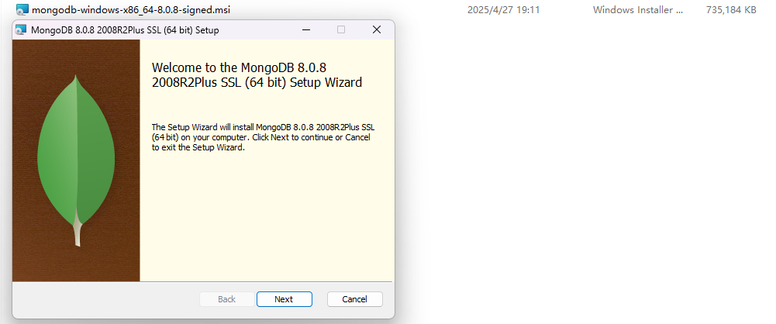

Then accept the license and chose Custom Install options, then we can install the components we want and the install position we want.

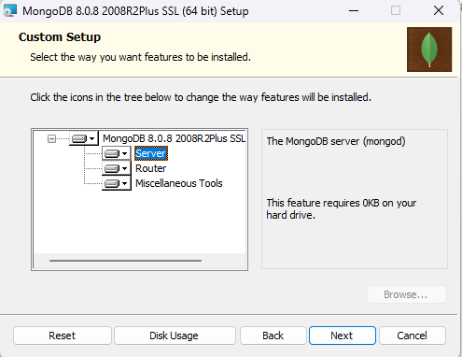

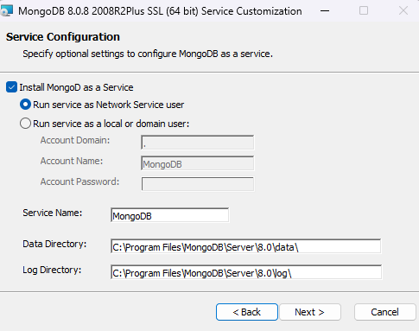

Leave other options as default.

Then, we can choose whether to install Campass or not.

**MongoDB Compass** is the official graphical user interface (GUI) provided by MongoDB for interacting with MongoDB databases. It allows users to visually explore their data, construct queries, optimize performance, and manage indexes without having to use the MongoDB Shell or write complex command-line scripts.

Key features of MongoDB Compass include:

* **Schema Visualization**: Automatically analyzes and displays the structure of collections, helping users understand their data models quickly.
* **Query Building**: Offers an intuitive, point-and-click interface to construct and run queries without requiring deep knowledge of MongoDB’s query syntax.
* **Data Browsing and Editing**: Enables users to view documents, edit fields, insert new documents, and delete records directly through the GUI.
* **Performance Monitoring**: Provides real-time insights into database performance, including server status, slow queries, and index usage.
* **Index Management**: Allows creation, deletion, and inspection of indexes, which are critical for optimizing database performance.
* **Aggregation Pipeline Builder**: Helps users construct and test complex aggregation pipelines with a visual, step-by-step interface.

Compass is especially helpful for beginners to learn MongoDB’s capabilities and for experienced developers to efficiently manage large datasets and optimize queries.

In this project, we chose to install MongoDB Compass along with MongoDB Server to facilitate data exploration, query testing, and performance analysis during the experimentation phase.

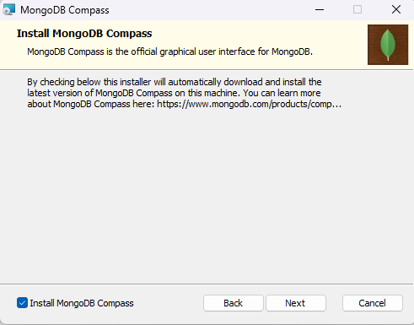

Then click install. Wait till the installation complete.

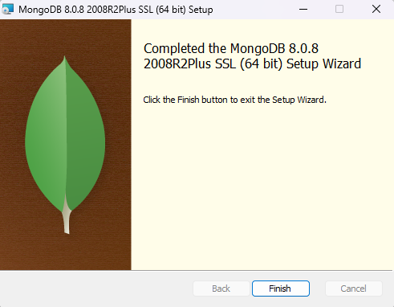

#### 3.1.3 Initial Configuration & verification (successful screenshots)

First, we need to check whether the bin dictionary was added to the System Environment Variables, So that we can directly execute MongoDB commands by opening the command line from anywhere.

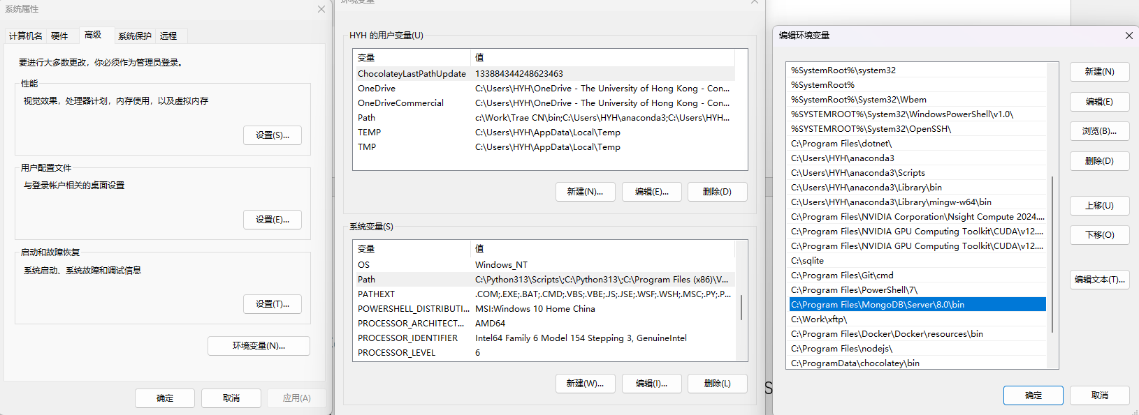

Then, we need to create a new folder in the data folder of the bin folder directory, because before starting the MongoDB service, we need to create a storage folder for the database files, otherwise the command will not be automatically created and cannot start successfully.



Then, start the MongoDB server using the db dictionary we just created.



When you see the port 27017 was opened, then the server is started.



Then, we can access this port:

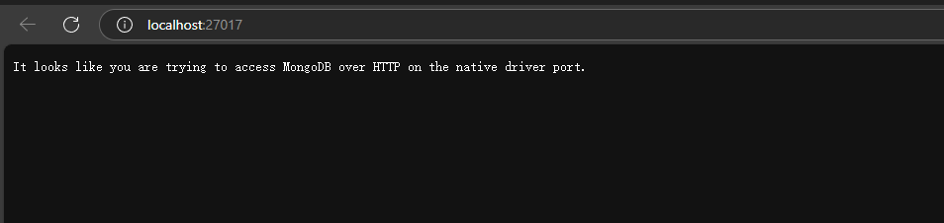

We can push “Ctrl + C” to end this process.

#### 3.1.4 Issues Encountered and Solutions (if any)

**1. Unable to recognize mongosh:**

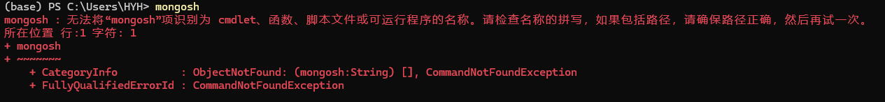

After installing MongoDB Community Server, attempting to run mongosh from the command line resulted in an error indicating that the command was not found.

Starting from MongoDB 6.0, the legacy mongo shell has been deprecated. The new MongoDB Shell (mongosh) is distributed as a separate installer and is **not bundled by default** with the MongoDB Server installation package.

**Solution**:

* Download MongoDB Shell (mongosh) separately from the official MongoDB website: <https://www.mongodb.com/try/download/shell>
* Install the downloaded mongosh installer.

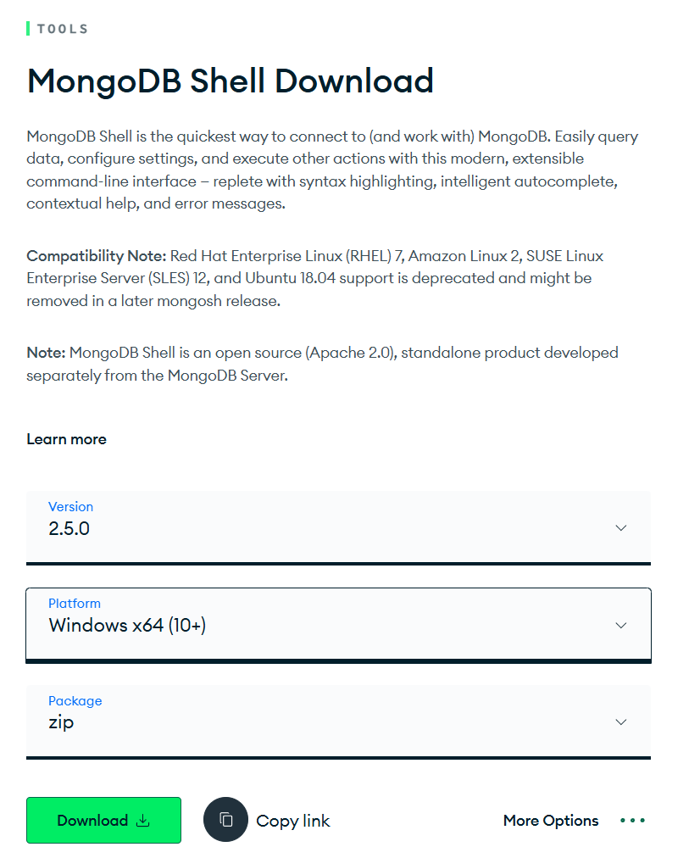

* After installation, verify that mongosh is available from the command line.
* (Optional) Add the installed mongosh path to the Windows Environment Variables if it is not automatically set.

Then, we can use mongosh.

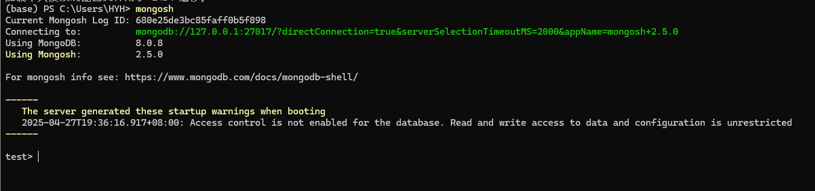

**2. Port 27017 Already in Use**

When attempting to start the MongoDB server manually, an error appeared indicating that port 27017 was already occupied.

**Possible Causes**:

* Another application (or an existing MongoDB instance) was already listening on port 27017.

**Solution**:

* Identify the conflicting application:

**netstat -ano | findstr :27017**

* Kill the conflicting process using:

**taskkill /PID <pid> /F**

* Alternatively, modify mongod.cfg to use a different port.

### 3.2 Docker-based Installation

#### 3.2.1 Environment Requirements

We need to install WSL2 to support the normal operation of Docker Windows clients.

#### 3.2.2 Docker Pull & Run Commands

First, we can run **docker search mongo** command.

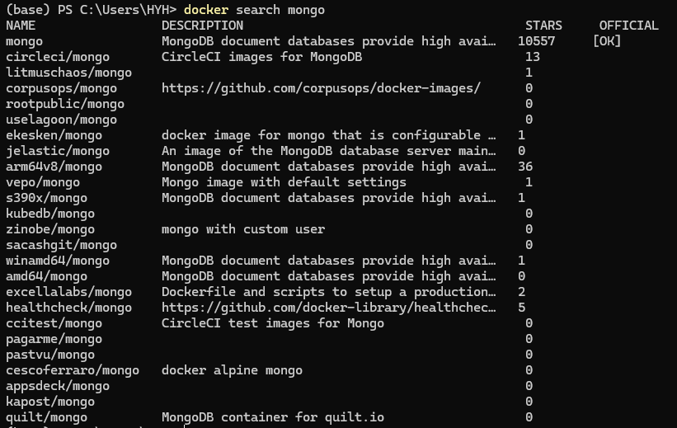

Then, we can pull the image.

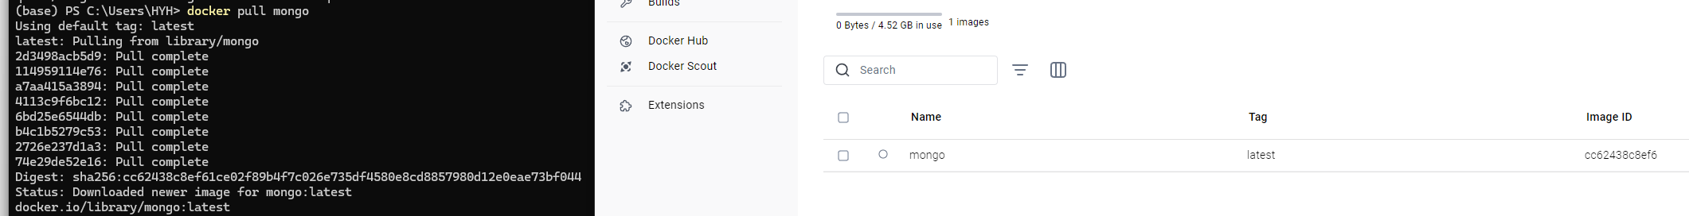

Then, we can run the image to create a container.

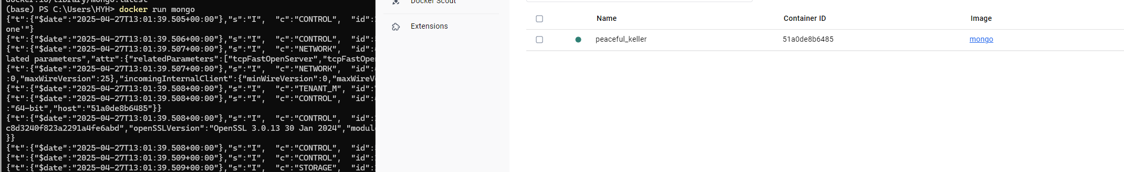

## Exploration & Experiments

### 4.1 Dataset Selection

For this project, I selected an environmental sensor dataset rather than a traditional network dataset from SNAP. The dataset consists of **air quality measurements collected in Nairobi, Kenya (**[**https://www.kaggle.com/datasets/pexpeter/air-quality-in-nairobi**](https://www.kaggle.com/datasets/pexpeter/air-quality-in-nairobi)**)**, and was sourced from publicly available environmental monitoring projects. This decision was made to better align with MongoDB’s strengths in handling semi-structured, time-series data, as opposed to graph-structured network data.

**Dataset Overview**

* **Name**: Nairobi Air Quality Dataset
* **Type**: Environmental Sensor Readings
* **Description**:

The dataset contains records of air quality metrics, including particulate matter (PM1.0, PM2.5, PM10), temperature, and humidity. Each record is associated with a sensor ID, location coordinates (latitude and longitude), a timestamp, and value-specific information.

* **Fields**:
  + sensor_id: Unique identifier for each sensor.
  + sensor_type: Type of measurement (e.g., P0, P1, P2, temperature, humidity).
  + location: Location ID of the sensor.
  + lat: Latitude coordinate.
  + lon: Longitude coordinate.
  + timestamp: Time of data recording.
  + value_type: Category of the recorded value (PM1.0, PM2.5, PM10, temperature, or humidity).
  + value: Measurement value.
  + source_file: Original file where the record was sourced.
  + source_month: Month corresponding to the measurement.

**Rationale for Selection**

* **Suitability for MongoDB**:

The dataset’s semi-structured nature, variable fields, and time-series characteristics make it an ideal candidate for storage and analysis within a document-oriented database like MongoDB.

* **Real-world Relevance**:

Air quality monitoring is a significant real-world application area for big data technologies, especially in smart city and environmental research domains.

* **Data Volume**:

The dataset consists of approximately 15 million records, providing a sufficiently large scale to test MongoDB’s scalability and performance under realistic conditions.

### 4.2 Basic commands and operations

* **View all current databases**:

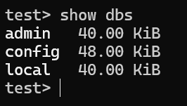

* **Create new database:**

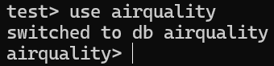

* **Create and show new collection:**

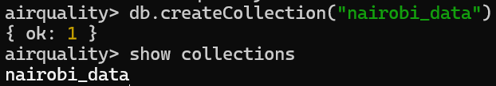

* **Insert an example document:**

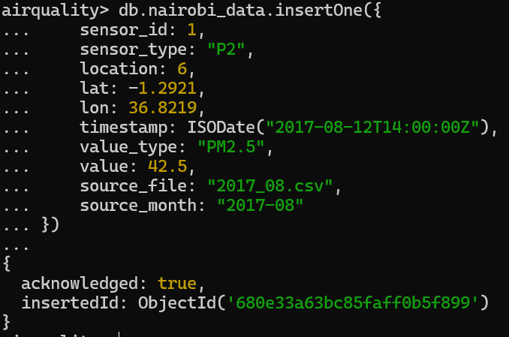

* **Query all documents in the collection:**

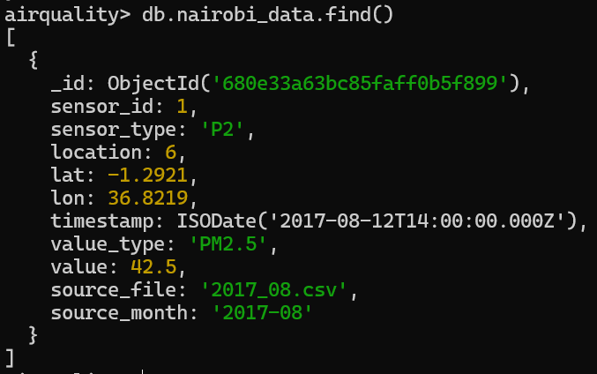

* **Query documents with specific conditions:**

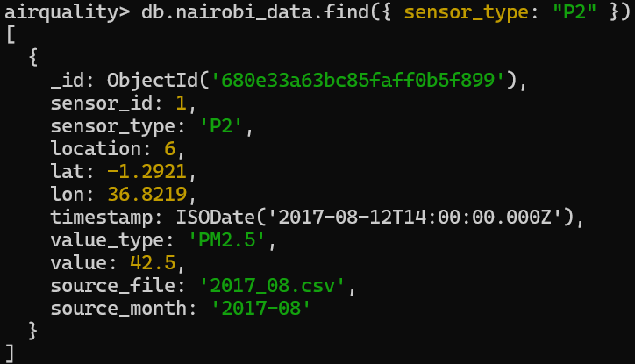

* **The query value is greater than a certain threshold:**

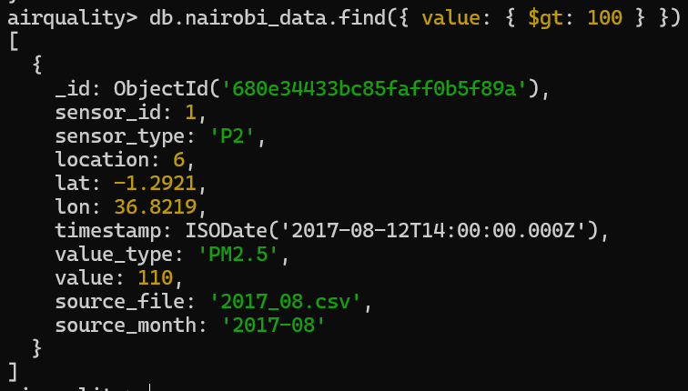

* **Query data for a certain month:**

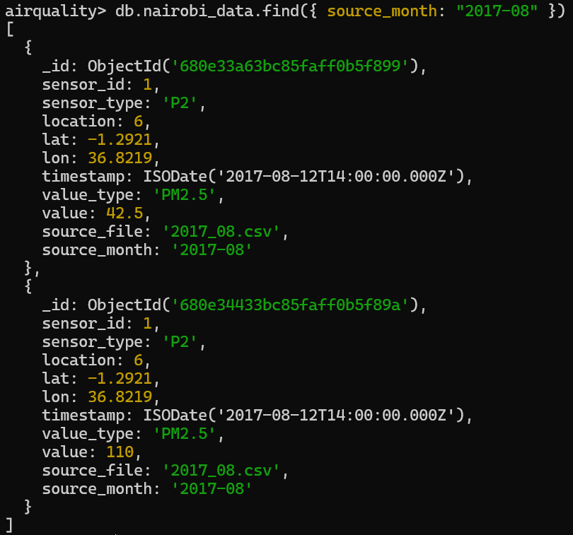

* **Index the timestamp field:**



* **Delete all files in the collection:**

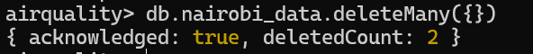

### 4.3 Advanced functional testing

#### 4.3.1 Data preprocessing

Before we import these dataset into MongoDB, we need to check the data integrity. So, we first check the proportion of missing values in the dataset.

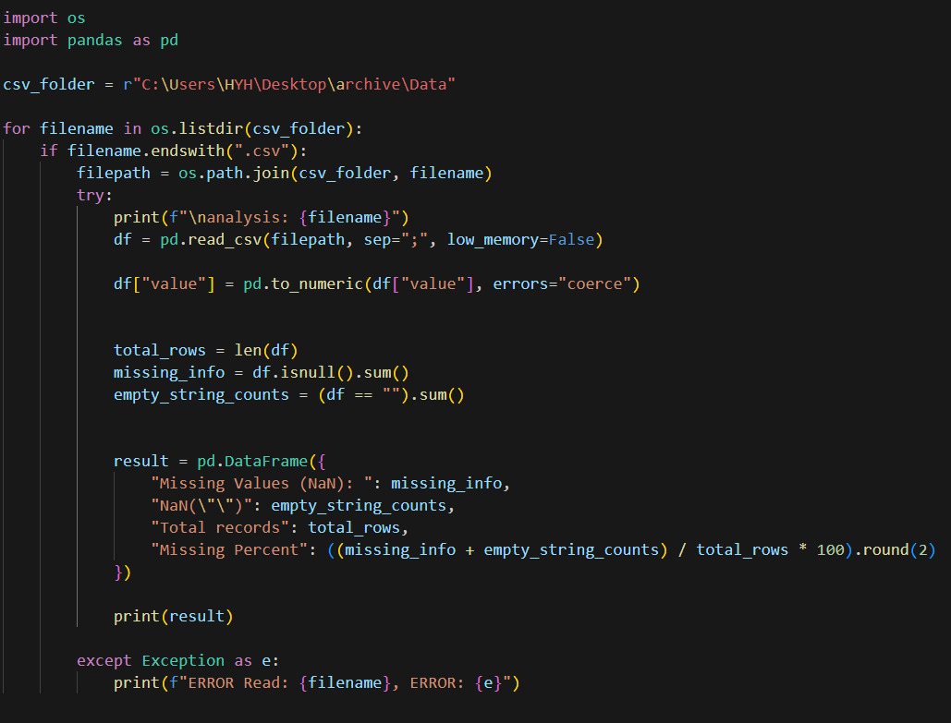

We run this Code Block:

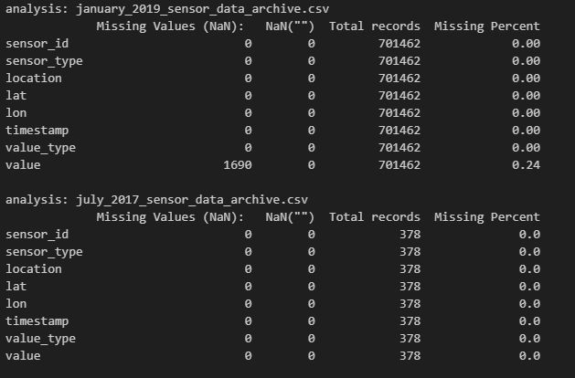

We found that there are still many missing values in CSV files. However, since the proportion of missing values is not particularly high, we can simply delete them.

Then, we can import all the data to the MongoDB.

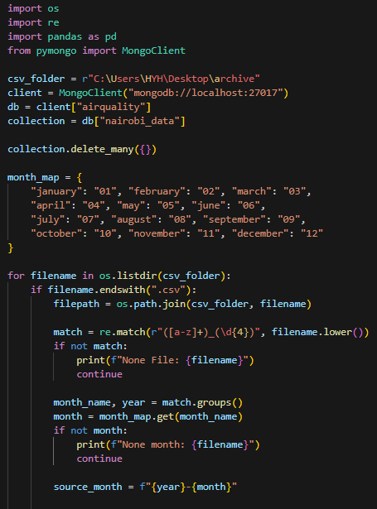 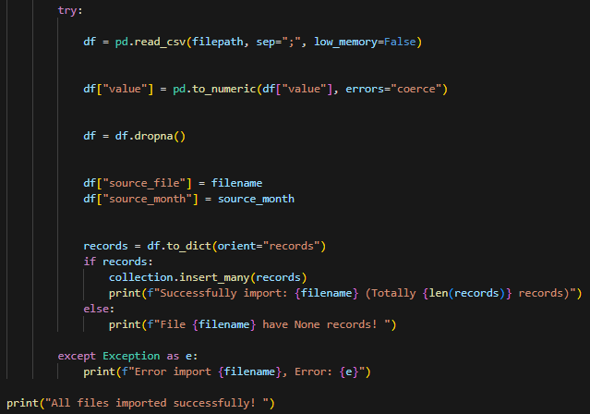

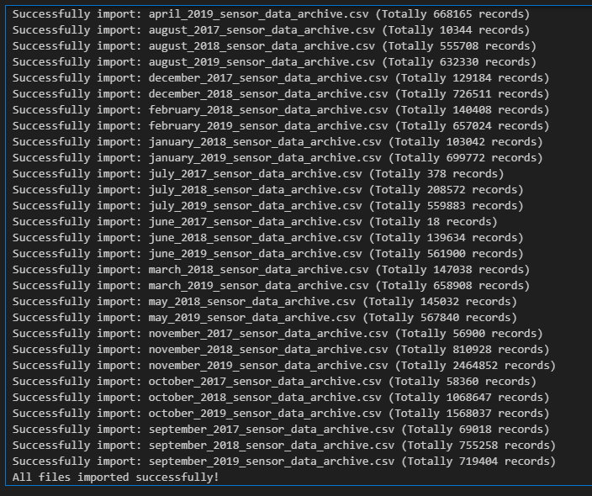

Then, we can simply see whether we successfully import the data in MongoDB Campass.

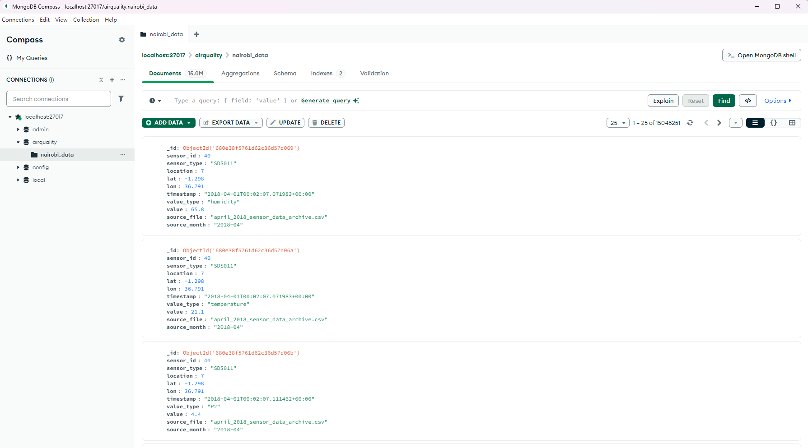

But when we were going to analyze it next, we accidentally found that the dataset was actually mixed with a lot of untrue data, such as the temperature in Nairobi being below minus 40 degrees Celsius, or the concentration of air pollutants reaching tens of thousands.

So, next, we processed these imported data and used MongoDB's own query condition construction to remove these outliers.

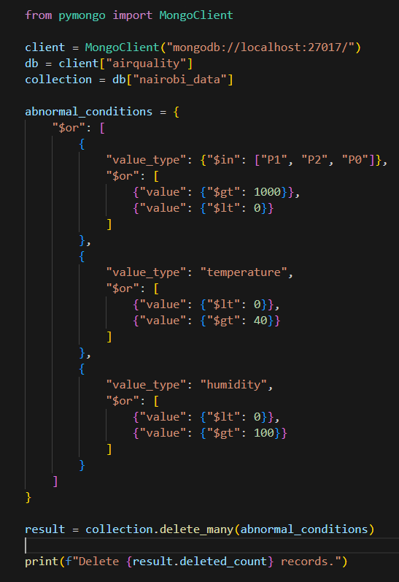

In the end, we successfully removed the outliers from the database.

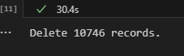

#### 4.3.2 Time series analysis

We first used the aggregation pipeline in MongoDB to perform time series analysis on the basic climate data changes at each location in the dataset.

That is, the average monthly PM2.5, PM10, temperature, humidity, and pollutant concentrations less than 1 micron at each collection point in the city of Nairobi over time in the dataset.

Among them, the design of the aggregation pipeline is as follows:

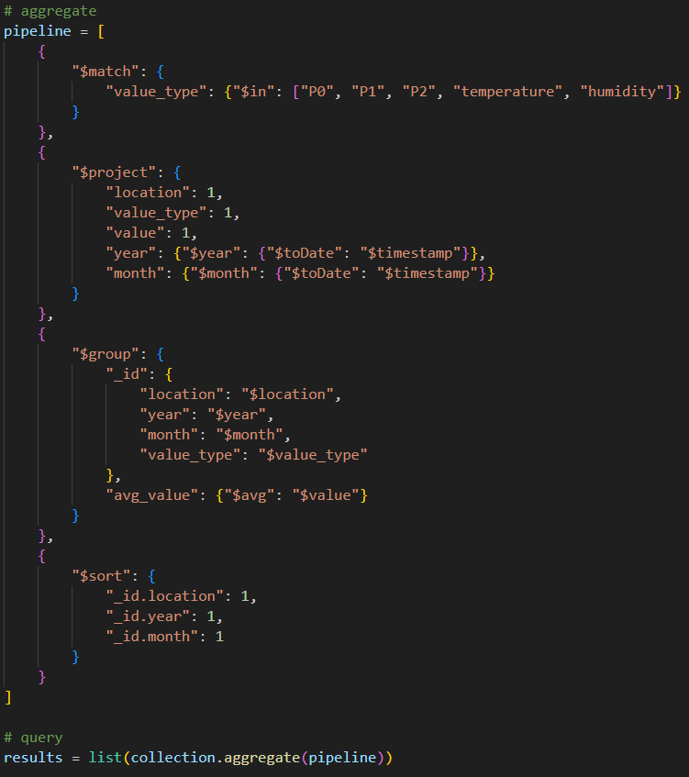

**Pipeline Stages**

* **match:**

The first stage filters the documents to retain only those where the value_type field is one of the following: "P0", "P1", "P2", "temperature", or "humidity".

This step ensures that only relevant environmental measurements are processed.

* **project:**

In the projection stage, I selected only the necessary fields for further analysis: location, value_type, and value.

Additionally, the timestamp field was converted to a date format using $toDate, and two new fields year and month were extracted using $year and $month operators, respectively.

* **group:**

This stage groups the documents based on four fields: location, year, month, and value_type.

For each group, it computes the average value of the value field using the $avg aggregation operator.

This enables the analysis of trends over time and across different locations and measurement types.

* **sort:**

Finally, the grouped results are sorted in ascending order by location, year, and month to facilitate structured analysis and visualization.

**Summary**

This aggregation pipeline efficiently summarizes the temporal and spatial distribution of air quality indicators by calculating the average readings per location and per month.

It highlights the strength of MongoDB's aggregation framework in performing complex analytical queries directly within the database without the need for external data processing tools.

Then, we can visualize the results we get (We save the time series analysis of each location in separate HTML files).

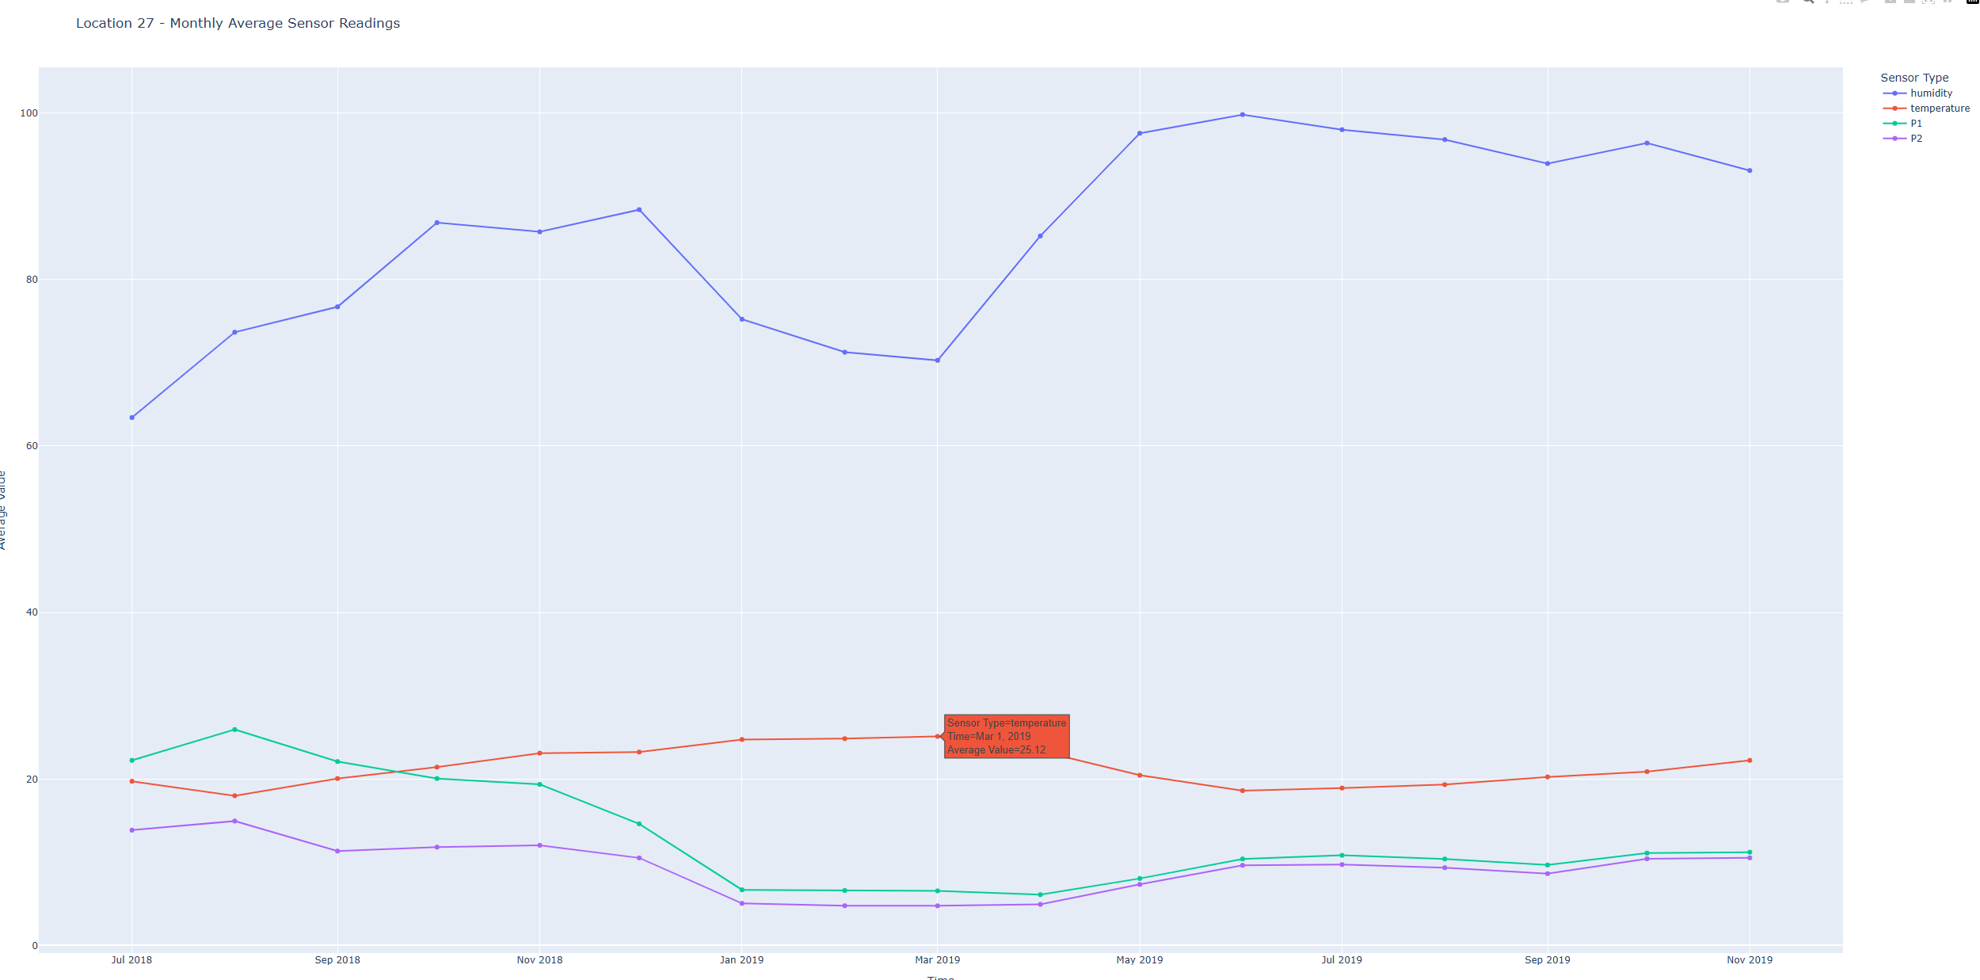

#### 4.3.3 Air Quality Score Calculation and Heatmap Generation

In this section, we focus on calculating air quality scores based on the data stored in MongoDB and generating an interactive heatmap. The air quality score serves as a comprehensive metric to evaluate the overall air quality at different locations, taking into account multiple environmental factors. This approach allows for a more intuitive understanding of air quality patterns across the study area.

**Location Coordinates Extraction**

To prepare for spatial visualization, we extract the latitude and longitude for each location from the MongoDB collection:

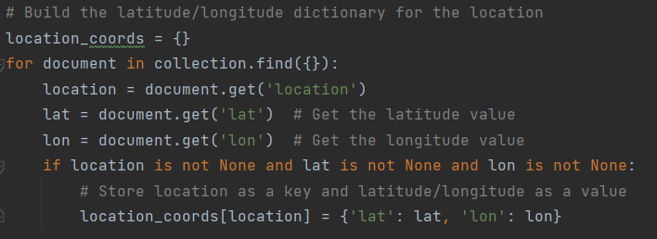

This step creates a dictionary location_coords that maps each location identifier to its corresponding geographic coordinates, enabling the placement of data points on a map.

**Air Quality Score Calculation**

We define a function calculate_air_quality_score to compute a weighted score based on PM10, PM2.5, PM1.0, temperature, and humidity:

**Detailed Calculation Process:**

* Weight Assignment: Each environmental factor is assigned a weight based on its relative importance to air quality. PM10, PM2.5, PM1.0, temperature, and humidity have weights of 0.30, 0.25, 0.20, 0.15, and 0.10 respectively.
* Maximum Values and Optimal Conditions: Reasonable maximum values are set for pollutants (PM10: 150, PM2.5: 75, PM1.0: 50) and optimal conditions for temperature (20°C) and humidity (50%).

**Individual Score Calculation:**

* For pollutants (PM10, PM2.5, PM1.0), the score decreases linearly as the pollutant concentration approaches the maximum value. If the concentration exceeds the maximum, the score is zero.
* For temperature and humidity, the score decreases linearly as the value deviates from the optimal condition.

**Weighted Sum**: The individual scores are combined into a weighted sum, which is then scaled to a 0-100 range, with higher scores indicating better air quality.

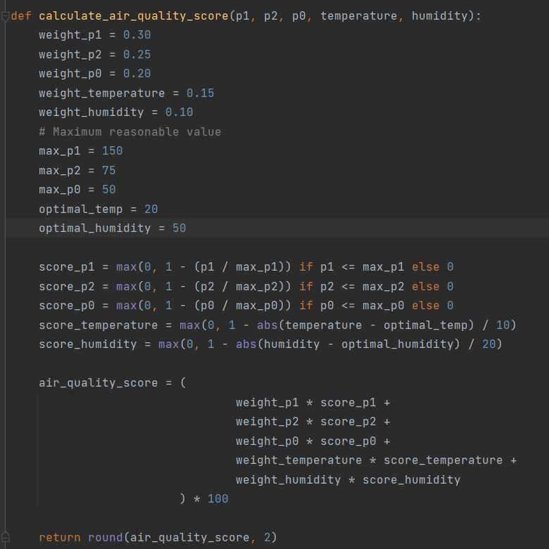

* **Data Aggregation and Processing**

We read a CSV file containing aggregated monthly average values for each location and filter the data to include only the relevant environmental metrics.

For each location, we compute the average values of PM10, PM2.5, PM1.0, temperature, and humidity:

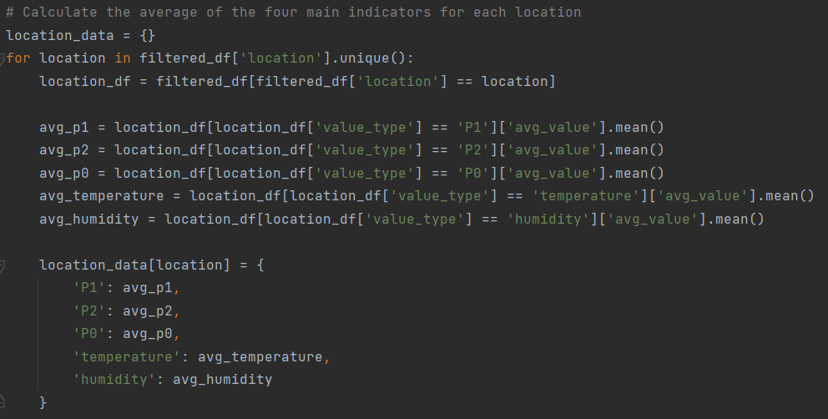

This step aggregates the data and prepares it for score calculation.

* **Heatmap Generation**

Using the Folium library, we create an interactive heatmap to visualize the air quality scores across different locations:

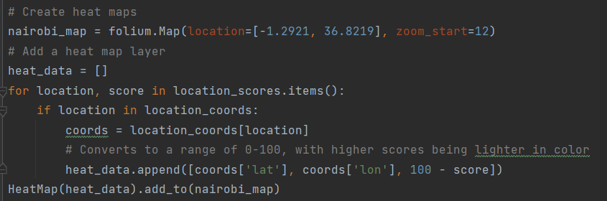

The heatmap visually represents the air quality, with colors ranging from red (poor air quality) to green (good air quality), providing an intuitive spatial analysis tool.

* **Summary**

This section showcases the integration of MongoDB data with Python analytics libraries to calculate air quality scores and generate interactive visualizations. By leveraging MongoDB's flexibility and Python's powerful data processing capabilities, we transform raw environmental sensor data into actionable insights, enabling effective monitoring and analysis of air quality patterns. This approach not only highlights MongoDB's utility in handling real-world environmental data but also demonstrates the potential for further advanced analytics and decision-making support in smart city and environmental monitoring applications.

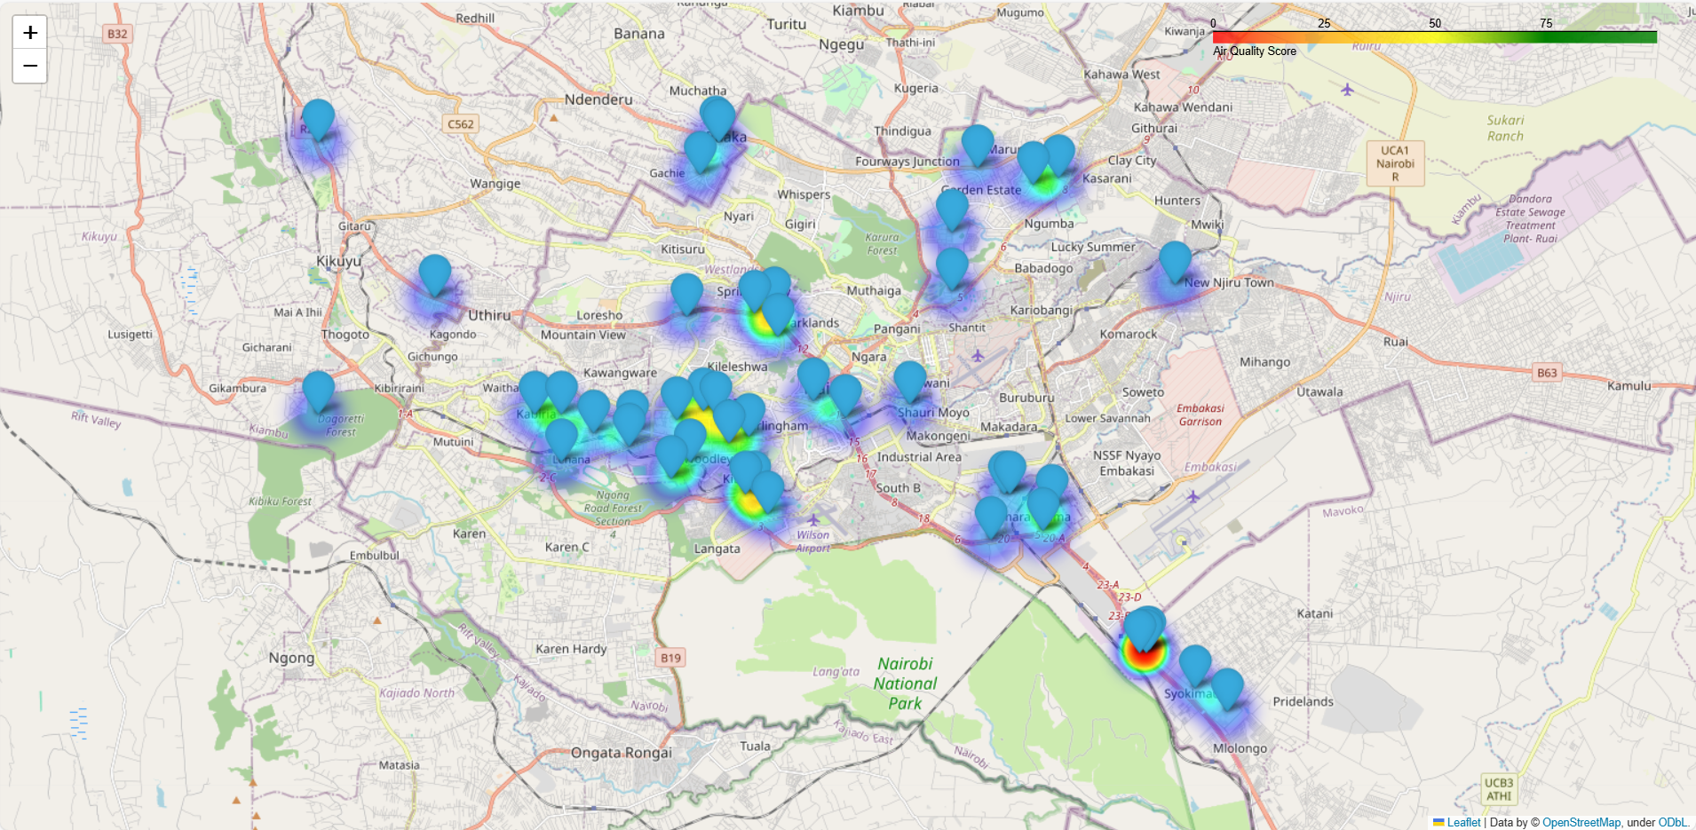

#### 4.3.4 Data visualization from MongoDB database

* **Data Visualization Display & Data Structure Analysis:**

In MongoDB, we focus on five key value types for data visualization:

- P1 (PM10)

- P2 (PM2.5)

- P0 (particles <1 micrometer)

- Temperature

- Humidity

Each data entry in MongoDB represents a single value type and includes:

Location，Timestamp，Source file and Source month.

This structure allows for detailed tracking and analysis of air quality metrics while maintaining clear data provenance.

**Temperature:**

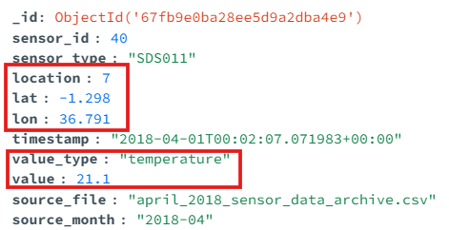

**Humidity:**

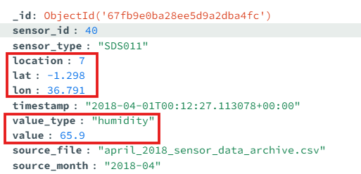

**P0:**

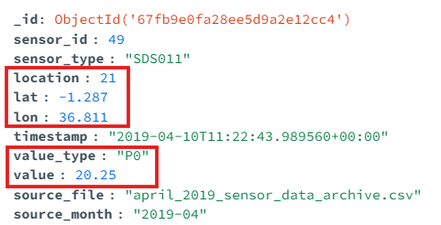

**P1:**

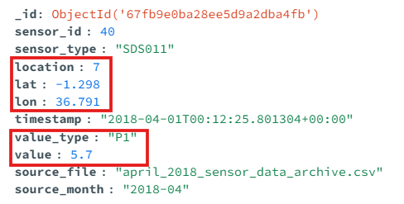

**P2:**

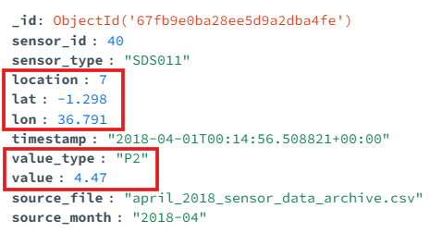

* **Data Selection for Visualization:**

In practical applications, recent data holds greater research value for users. Hence, in this analysis, we showcase the most recent five data points for P0, P1, P2, temperature, and humidity across all locations. As all location data includes latitude and longitude, we display the corresponding addresses on a map. When the address icon is clicked, it reveals the display time range and specific data for each type. If there are fewer than five data points, the display shows "null".

* **Key Feature Implementation Codes：**

1. **Connection to database:**

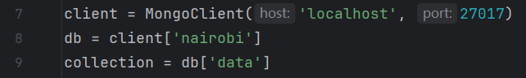

client = MongoClient('localhost', 27017)

This line of code connects to the MongoDB database service on localhost at port 27017 (MongoDB's default port).

db = client['nairobi']

Then select the database named "nairobi". If it doesn't exist, MongoClient will automatically create it when needed.

collection = db['data']

In the "nairobi" database, select the collection named "data". If the collection does not exist, it will also be automatically created when data is inserted.

1. **Query the collection and group the data by location:**

documents = collection.find({},  
 {'_id': 0, 'lat': 1, 'lon': 1, 'location': 1, 'timestamp': 1, 'value': 1, 'value_type': 1})  
  
lat_lon_combinations = {}  
for doc in documents:  
 lat_lon = (doc['lat'], doc['lon'], doc['location'])  
 if lat_lon not in lat_lon_combinations:  
 lat_lon_combinations[lat_lon] = []  
 lat_lon_combinations[lat_lon].append(doc)

The **collection.find({})** operation retrieves all documents within the specified collection. The projection **{'_id': 0, 'lat': 1, 'lon': 1, 'location': 1, 'timestamp': 1, 'value': 1, 'value_type': 1}** is used to specify the fields to be returned in the result set. Here, setting **_id: 0** explicitly excludes the **_id** field from the results, while the other fields are set to 1, indicating that only these fields should be included in the output. Consequently, the code returns a list of documents that contain only the specified fields.

Subsequently, a **for** loop is employed to iterate over all the documents retrieved from the MongoDB query. During each iteration, the code extracts the **latitude**, **longitude**, and **location** from the current document and combines them into a tuple called **lat_lon**, which serves as a unique identifier for grouping. Finally, the current document **doc** is added to the list corresponding to the **(lat, lon, location)** tuple, effectively grouping the documents by their location.

1. **Visualizing location data through HTML:**

if lat_lon_combinations:  
 lats, lons, sensor_ids = zip(*lat_lon_combinations.keys())  
 center_lat = sum(lats) / len(lats)  
 center_lon = sum(lons) / len(lons)  
 map_center = [center_lat, center_lon]  
 zoom_level = 13  
else:  
 map_center = [0, 0]  
 zoom_level = 2  
  
m = folium.Map(location=map_center, zoom_start=zoom_level)

The location serves as the map's center point, while **zoom_start** determines the map's zoom level. The code computes the average latitude and longitude to form a list **[center_lat, center_lon]**, pinpointing the map's center. The zoom level is set to 13, ideal for displaying city-scale views.

1. **Database Data Reading and Population:**

for lat_lon in lat_lon_combinations.keys():  
 lat, lon, location = lat_lon  
  
 recent_docs_temperature = list(collection.find(  
 {'lat': lat, 'lon': lon, 'value_type': "temperature"},  
 {'_id': 0, 'location': 1, 'timestamp': 1, 'value': 1, 'value_type': 1}  
 ).sort('timestamp', -1).limit(5))  
  
 while len(recent_docs_temperature) < 5:  
 recent_docs_temperature.append({  
 'location': location,  
 'timestamp': "null",  
 'value': "null",  
 'value_type': "null"  
 })

For each unique geographical location, retrieve the most recent five records of data_type from the MongoDB database. If there are fewer than five results, pad with a default value (null) to ensure the final dataset always contains five records.

1. **Integrating MongoDB data into an HTML map visualization:**

popup_content = (f"<b>Location:</b> {location}<br>"  
 f"<b>Recent temperature:</b> from {recent_docs_temperature[4]['timestamp']} to {recent_docs_temperature[0]['timestamp']}<br>"  
 f"<b>values:</b> {', '.join(str(doc['value']) for doc in recent_docs_temperature)}<br>"  
 f"<b>Recent humidity:</b> from {recent_docs_humidity[4]['timestamp']} to {recent_docs_humidity[0]['timestamp']}<br>"  
 f"<b>values:</b> {', '.join(str(doc['value']) for doc in recent_docs_humidity)}<br>"  
 f"<b>Recent P0:</b> from {recent_docs_P0[4]['timestamp']} to {recent_docs_P0[0]['timestamp']}<br>"  
 f"<b>values:</b> {', '.join(str(doc['value']) for doc in recent_docs_P0)}<br>"  
 f"<b>Recent P1:</b> from {recent_docs_P1[4]['timestamp']} to {recent_docs_P1[0]['timestamp']}<br>"  
 f"<b>values:</b> {', '.join(str(doc['value']) for doc in recent_docs_P1)}<br>"  
 f"<b>Recent P2:</b> from {recent_docs_P2[4]['timestamp']} to {recent_docs_P2[0]['timestamp']}<br>"  
 f"<b>values:</b> {', '.join(str(doc['value']) for doc in recent_docs_P2)}<br>"  
 )  
  
folium.Marker([lat, lon], popup=folium.Popup(popup_content, max_width=300)).add_to(m)  
  
popup = folium.Popup(popup_content, max_width=300)  
  
folium.Marker([lat, lon], popup=popup).add_to(m)  
  
m.save("map.html")

In the popup_content, an HTML-formatted string was constructed for the map popup:

* Location: Display the geographical location using **location**.
* Recent temperature: Show the time range of the five latest temperature records, from the earliest (**recent_docs_temperature**[4]) to the latest (**recent_docs_temperature**[0] and other data types).
* Values: List the specific values of the five latest temperature records, separated by commas.
* Recent humidity, P0, P1, P2: Similar to temperature, display the time ranges and values for these data types.
* Use the HTML tag <br> for line breaks to enhance readability.

After constructed a html page, the code add a marker to the map using **folium.Marker**, specifying the position with **[lat, lon]** and setting the popup content. Limit the popup width to 300 pixels. Finally, we add the marker to the map object **m**. The generated HTML page is named map.html.

* **Result display:**

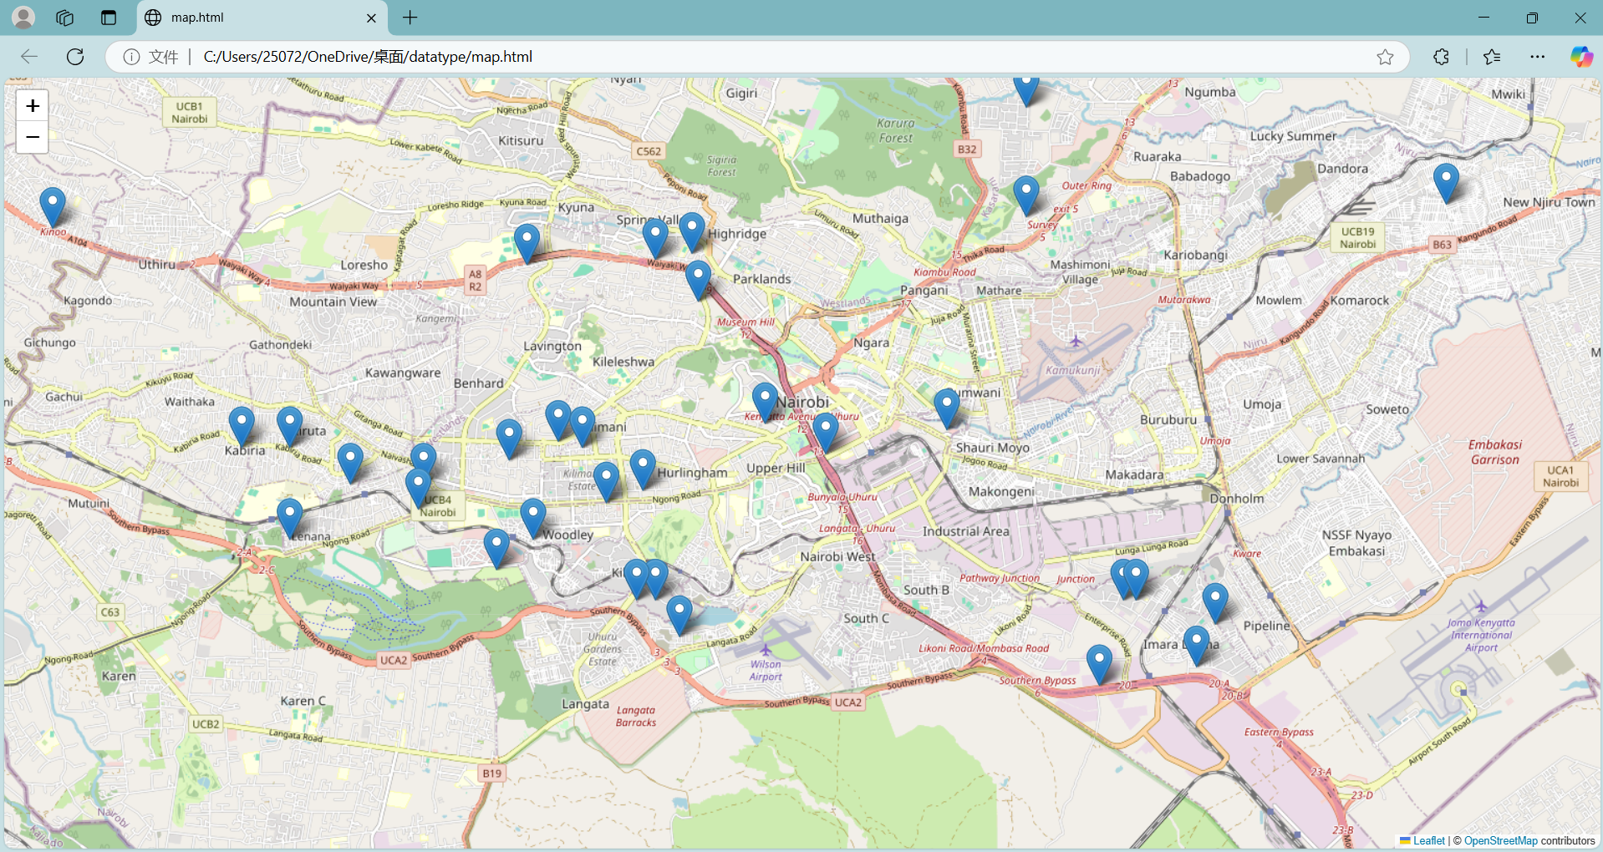

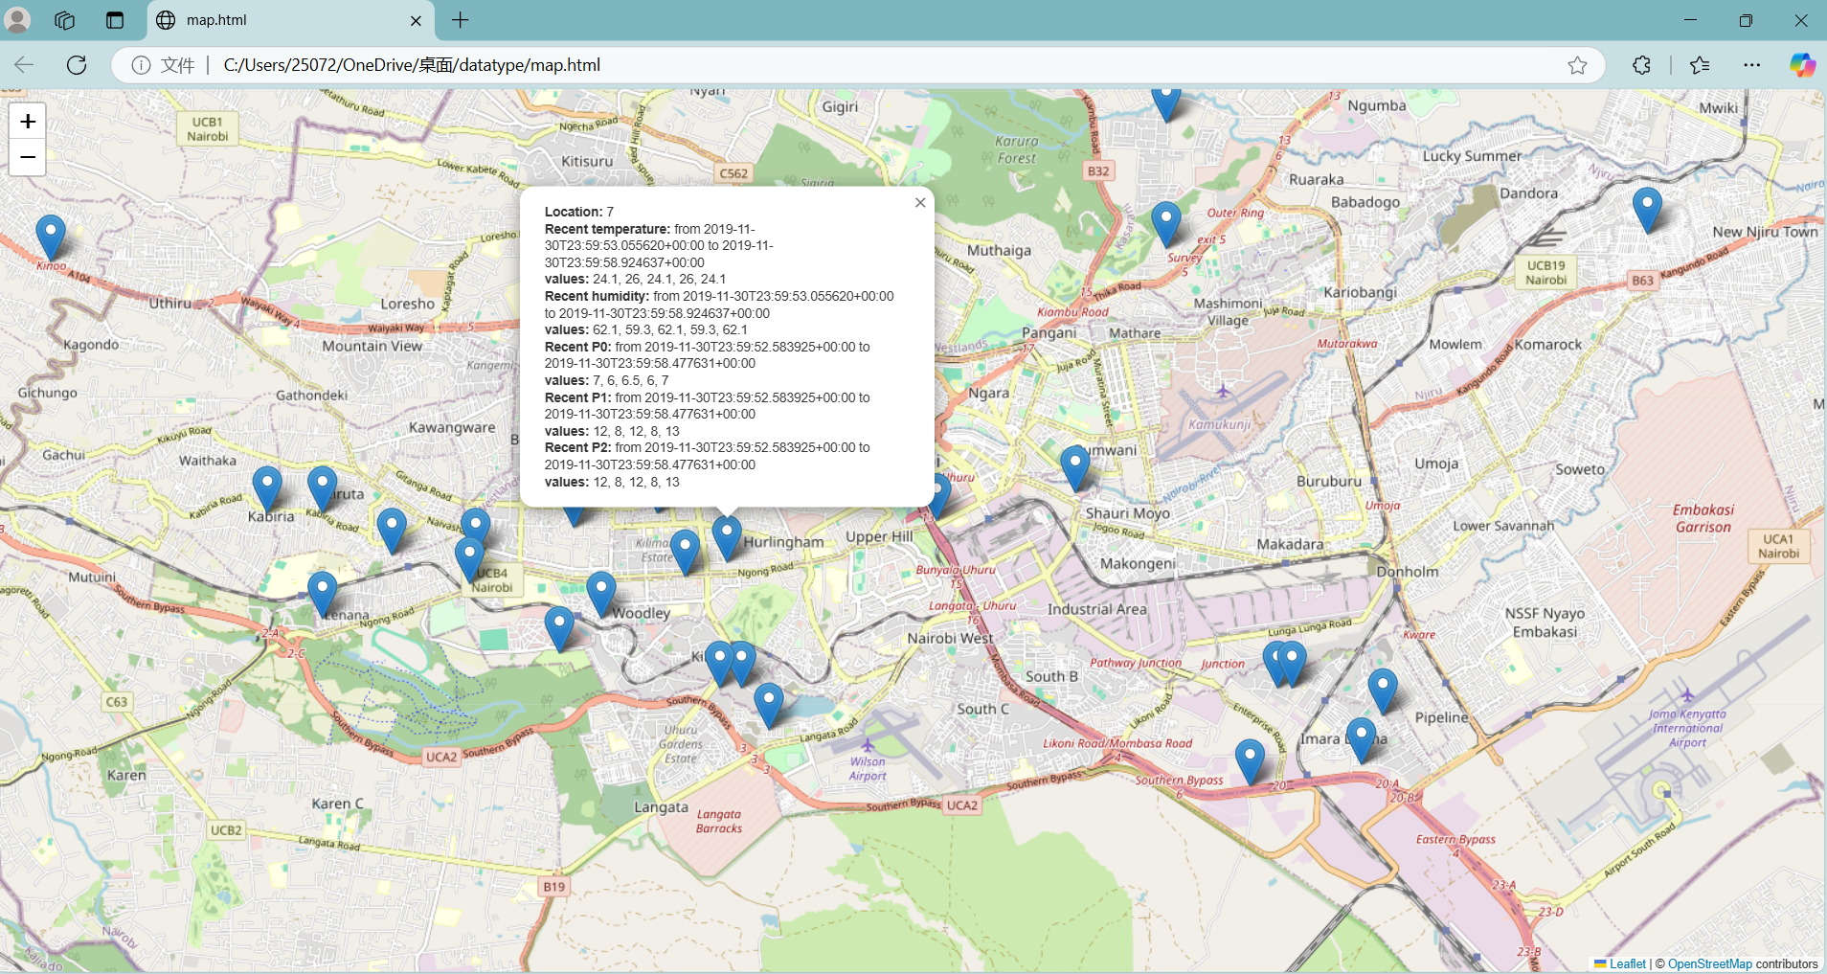

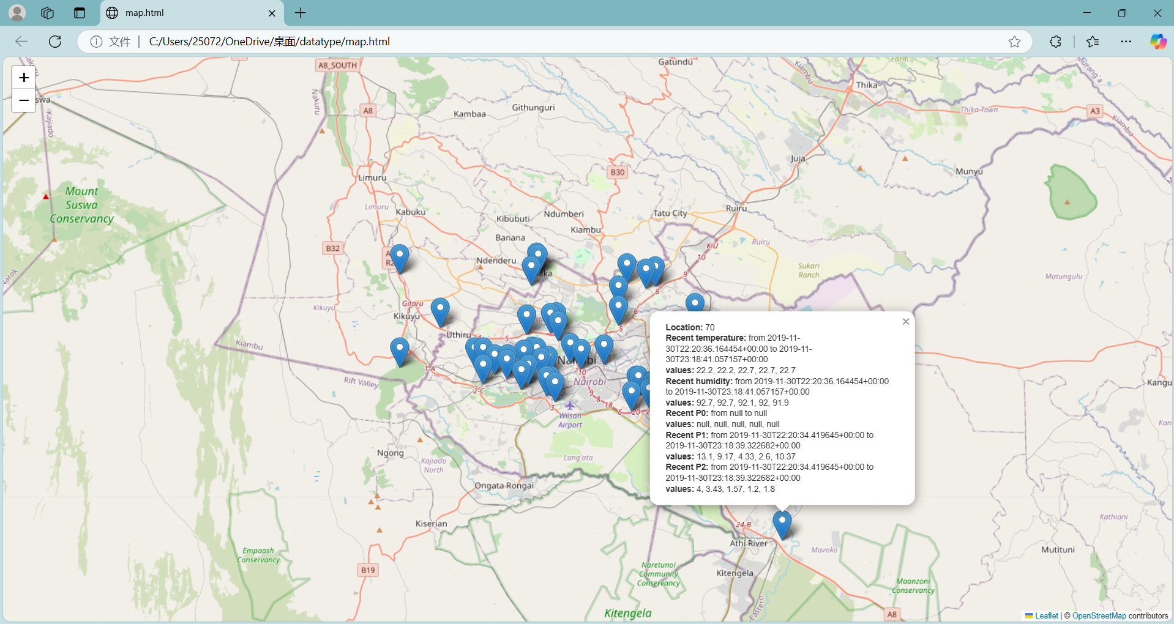

## Evaluation & Analysis

#### 5.1 Strengths of MongoDB

MongoDB offers several advantages that make it a preferred choice for modern application development:

* **Flexible Schema Design**: MongoDB's document-oriented model allows for dynamic schema, enabling developers to store unstructured or semi-structured data without predefined schemas. This flexibility accelerates development cycles and accommodates evolving data requirements.​[GeeksforGeeks](https://www.geeksforgeeks.org/mongodb-advantages-disadvantages/?utm_source=chatgpt.com)
* **Horizontal Scalability**: Through sharding, MongoDB can distribute data across multiple servers, facilitating horizontal scaling to handle large volumes of data and high-throughput operations. This design supports applications requiring scalability and high availability.​[alronz.github.io+4fynd.academy+4MongoDB+4](https://www.fynd.academy/blog/advantages-of-mongodb?utm_source=chatgpt.com)
* **High Performance**: MongoDB provides efficient data access through indexing and in-memory storage, resulting in low-latency read and write operations. Its performance is particularly notable when the working set fits into memory.​[MongoDB](https://www.mongodb.com/resources/products/capabilities/performance-best-practices?utm_source=chatgpt.com)
* **Rich Query Language and Aggregation Framework**: MongoDB supports a powerful query language and aggregation framework, enabling complex data retrieval and transformation operations directly within the database.​[fynd.academy](https://www.fynd.academy/blog/advantages-of-mongodb?utm_source=chatgpt.com)
* **Comprehensive Ecosystem**: With MongoDB Atlas, the fully managed cloud service, users benefit from automated backups, monitoring, and seamless scalability, reducing operational overhead.​

#### 5.2 Weaknesses of MongoDB

Despite its strengths, MongoDB has certain limitations:

* **Limited Support for Complex Transactions**: While MongoDB introduced multi-document ACID transactions in version 4.0, their performance and complexity management are not on par with traditional relational databases, making it less suitable for applications requiring complex transactional operations.​[designgurus.io+1fynd.academy+1](https://www.designgurus.io/answers/detail/what-are-the-disadvantages-of-mongodb?utm_source=chatgpt.com)
* **High Memory Consumption**: MongoDB's performance is optimal when the working set resides in memory. Large datasets exceeding available memory can lead to increased disk I/O and degraded performance.​[MongoDB](https://www.mongodb.com/resources/products/capabilities/performance-best-practices?utm_source=chatgpt.com)
* **Lack of Native Joins**: MongoDB does not support traditional joins as in relational databases. Implementing relationships between collections often requires manual referencing and additional application-side logic, complicating data modeling.​[designgurus.io](https://www.designgurus.io/answers/detail/what-are-the-disadvantages-of-mongodb?utm_source=chatgpt.com)
* **Steep Learning Curve**: For teams accustomed to relational databases, transitioning to MongoDB's document model and understanding its indexing, sharding, and replication mechanisms can present a learning challenge.​[fynd.academy](https://www.fynd.academy/blog/advantages-of-mongodb?utm_source=chatgpt.com)
* **Storage Overhead**: Due to its BSON format, MongoDB may consume more storage compared to relational databases, as each document includes field names and metadata, leading to increased storage requirements.​

#### 5.3 Real-World Applications

MongoDB's features make it suitable for various industry applications:

* **Finance**: Financial institutions utilize MongoDB for real-time analytics, fraud detection, and customer data management, benefiting from its scalability and flexible data model.​[fynd.academy](https://www.fynd.academy/blog/advantages-of-mongodb?utm_source=chatgpt.com)
* **Transportation and Logistics**: Companies like Picap leverage MongoDB to manage ride-sharing services and logistics operations, utilizing its scalability and real-time data processing capabilities.​[MongoDB](https://www.mongodb.com/solutions/customer-case-studies/picap?utm_source=chatgpt.com)
* **Environmental Monitoring**: MongoDB is employed in storing and analyzing environmental sensor data, such as air quality measurements, due to its ability to handle time-series data and flexible schemas.​
* **Social Networks**: Platforms like LinkedIn use MongoDB to manage user profiles, connections, and activity feeds, capitalizing on its scalability and flexible data structures.​

#### 5.4 Comparison with Other Databases

When compared to other NoSQL and relational databases, MongoDB exhibits distinct characteristics:

* **Versus Cassandra**: MongoDB offers a more flexible data model and supports secondary indexes, facilitating complex queries. Cassandra, while excelling in write-heavy workloads and linear scalability, has limitations in query flexibility.​[Severalnines](https://severalnines.com/blog/battle-nosql-databases-comparing-mongodb-cassandra/?utm_source=chatgpt.com)
* **Versus Neo4j**: Neo4j, a graph database, is optimized for handling complex relationships and graph traversals. MongoDB, lacking native graph processing capabilities, is less suitable for applications requiring intricate relationship modeling.​
* **Versus Relational Databases (e.g., MySQL, PostgreSQL)**: Relational databases provide robust transaction support and structured schemas, making them ideal for applications with complex transactional requirements. MongoDB's flexible schema and scalability offer advantages for applications dealing with unstructured data and requiring rapid development cycles.​

## Reflection & Lessons Learned

Through the completion of this project, we gained valuable hands-on experience in working with a real-world big data tool, from installation and configuration to data ingestion, querying, and analysis.

Our exploration of MongoDB provided a practical understanding of its architectural principles, operational strengths, and the challenges that arise when applying it to large-scale data scenarios.

#### 6.1 Key Learnings

* We developed a comprehensive understanding of MongoDB’s flexible document-oriented data model, which differs significantly from traditional relational schemas.
* We became familiar with the complete installation process on both Windows systems and Docker environments, including troubleshooting common setup issues.
* We acquired practical skills in performing basic CRUD operations, constructing complex queries, and utilizing MongoDB's aggregation framework for data transformation and summarization.
* We recognized MongoDB's strengths in handling time-series and semi-structured data, especially in the context of environmental sensor datasets like the Nairobi air quality records.

#### 6.2 Major Challenges and How We Overcame Them

* **Managing Environment Setup**:

One of the initial challenges was the separate installation requirement for the MongoDB Shell (mongosh) in newer versions of MongoDB.  
We addressed this by consulting the official MongoDB documentation, downloading mongosh separately, and configuring the system environment variables properly.

* **Data Quality Issues**:

While working with the air quality dataset, we encountered a significant number of abnormal values, such as negative particulate matter readings and out-of-range temperature and humidity measurements.

To ensure meaningful analysis, we implemented a data cleaning phase using MongoDB queries and deletion filters.

* **Understanding Aggregation Pipelines**:

Initially, constructing complex aggregation pipelines to group and average data by location and time periods posed a challenge.

Through iterative testing and studying documentation and online resources, we successfully mastered building efficient pipelines for data analysis.

#### 6.3 Potential Extensions for Future Work

If more time and resources were available, we would extend this exploration in the following ways:

* **Performance Benchmarking**:

Conduct systematic performance evaluations by loading larger datasets and measuring query execution times under different indexing strategies.

* **Replication and Sharding**:

Set up a replica set and a sharded cluster to explore MongoDB’s horizontal scalability and fault tolerance mechanisms.

* **Integration with Visualization Tools**:

Integrate MongoDB with data visualization platforms (e.g., Power BI, Grafana) to build real-time dashboards for air quality monitoring.

* **Comparison with Other Databases**:

Conduct comparative experiments using other NoSQL databases such as Cassandra or time-series specialized databases like InfluxDB to evaluate relative strengths and weaknesses.

#### 6.4 Areas for Further Study

Through this project, we identified several areas that warrant further learning and exploration:

* **Advanced Indexing Techniques**:

Including compound, geospatial, and text indexes to optimize query performance on larger and more complex datasets.

* **Schema Design Best Practices**:

Investigating different schema modeling strategies to balance flexibility, performance, and maintainability in document-based databases.

* **Operational Aspects**:

Studying backup strategies, replica set maintenance, and disaster recovery procedures for production-level MongoDB deployments.